

Module Handbook

XTC/XTE-3210

PGCE Primary

2023-24 School Experience

# **CABAN PGCE School Experience** **XTC/XTE3210**

School experience is an essential aspect of all initial teacher education courses. This module is your opportunity to observe learners and teachers in school, to try out new ideas and professional experiences and, most importantly, to reflect and improve on your own practice.

**Overall aims and purpose**

This module will:

* Support you to develop a range of skills autonomously (including building on your knowledge of the Welsh language to promote ‘Cymraeg Pob Dydd’) and reflective practice to satisfy the requirements of the Professional Standards for Teaching and Leadership (PSTL) to become a qualified teacher and contribute to the learning community;
* Ensure you are thoroughly aware of how the application of knowledge and reflective practice provides enriched learning experiences for learners;
* Support you to independently identify a wide range of techniques to become critically reflective about you own professional development and integrate into the school environment;
* Provide opportunities for you to develop understanding of the content, principles and foci of XTC/XTE4211 and XTC/XTE4213 in context.

**Module Content**

The primary school-based experience module will develop your competency in teaching and learning. It will include collaboratively led close to practice seminars (in placement setting) that will inform how you teach and observe in the school. The structure will follow a progressive staged approach to learning how to teach. An indicative pattern is outlined below:

Stage 1: Preparatory (HEI and Lead schools)

Stage 2: Integration (HEI, Lead Schools and Network Schools)

Stage 3: Development (Network Schools supported by Lead schools and HEIs)

Stage 4: Practice and implementation (Network Schools supported by Lead schools and HEIs)

Stage 5: Debrief and reflection (HEI and Lead schools)

Stage 6: Further implementation in second school (Network Schools supported by Lead schools and HEIs)

Stage 7: Consolidation of subject knowledge skills and practice in second school (Network schools supported by Lead schools and HEIs)

Stage 8: Autonomous development and enrichment (Network schools supported by Lead schools and HEIs)

These stages will include:

* weekly cluster teaching and review events;
* observations and preparatory development;
* close to practice research (small scale inquiries);
* integration into the teaching environment;
* higher order skills practice and implementation;
* mentoring and self-reflection;
* further implementation through practice;
* consolidation of skills and practice;
* continued autonomous development and enrichment of your practice.

**Assessment**

During the module you will continually reflect on your progress with your colleagues and mentor and upload relevant evidence to the Personal Learning Passport. At the end of the module, you will demonstrate that you have made satisfactory progress against the Professional Standards for Teaching and Leadership. For this module, pass or fail is recorded at the exam board using the PSTL. All details of assessment against the PSTL are included in the PSTL Assessment Handbook and details of how to use the PLP are on available online.

**Learning outcomes**

*On successful completion of this module you will have*

* Critically examined the practices, assumptions and theories underpinning the planning for and structuring of pupils’ learning and the management of their behaviour in secondary schools from the perspective of policy, research, theory and current practice;
* Demonstrated a sophisticated understanding and experience of teaching that ensures all learners develop the capacity to be ambitious and capable, enterprising and creative, ethical and informed, healthy and confident as required by the curriculum;
* Demonstrated a profound understanding of Additional Learning Needs (ALN) from different perspectives and the evaluated steps taken to address them;
* Managed and organised classrooms to promote a culture of high aspiration and behaviour which supports learning;
* Enrich learners’ sense of community and cultural values by applying your knowledge of the Welsh curriculum;
* Reflected critically on your progress and collaboratively set targets with your mentor in order to meet or exceed the Professional Standards for Teaching and Leadership.

**Progression in Bilingualism**

You will be introduced to bilingualism in the context of the distinct Welsh curriculum, and the different ways that this is addressed in the different school settings (Welsh medium, bilingual and English medium). You will also study the aims and goals of bilingual education from different perspectives, consider EAL education and look at the specific issues associated with assessment of bilinguals. Subsequently you will consider the expected and realistic outcomes for different types of bilinguals. You will be made aware of and come to understand language policies in operation in schools and specific strategies that are built into the curriculum to address learners' language skills.

**Research informed delivery and research-based teaching**

The content and delivery of the module will encourage you to offer advanced critical review of the importance of being consumers and producers of research and to analyse, synthesise and critically reflect on the spectrum of research that informs teaching practice. You will also critically evaluate practice-based and close-to-practice research. The module will develop your knowledge of a ‘culture of enquiry’ within self-improving school systems, schools as learning organisations, and the importance of developing and participating in Professional Learning Communities. Specific research shared during network events will link closely to the content of XTE-4211 and XTE-4213 and will be used to inform assessments for these modules.

**The Professional Journal**

Throughout the module you will have many opportunities to observe, practice and reflect. You will keep research notes in a professional journal which is structured to support your progress as a new AT.

**Professional Responsibilities**During your school placement, you should complete the following activities:

* Accompany a teacher on duty one day a week.
* Assist with class’s administrative duties under the guidance of the mentor or form tutor
* Prepare a display of children’s work

**Legal Requirements**

* Obtain a copy of school’s Child Protection, Anti-Bullying, Discipline and Restraint Policy (this may be an electronic or hard copy).
* Ensure you complete the child safeguarding page for both the lead school and the network school in your professional journal.
* Read the code of professional conduct online before the placement starts and complete the table in your JournalCaban’s Eight Stages of AT Development (Dates included in the weekly breakdown in this handbook)

# Reflective Practice

In addition to the initial induction to effective teaching this module will focus on two essential practitioner research skills: observation and reflection. You will use three theoretical models to frame your analysis of learning and teaching

## Ebbutt’s Questions

When observing or reflecting on learning and teaching, use the following questions to facilitate your analysis of learning and reflection on practice:

* *What did the pupils actually do?*
* *What were they learning?*
* *How worthwhile was it?*
* *What did I do? (What did the teacher do?)*
* *What did I learn?*
* *What do I intend to do next?*

Ebbutt, 1985, in Hopkins, D., 2014. *A teacher's guide to classroom research*. London, UK: McGraw-Hill Education

## Lesson Study

Secondly, during your first placement, you will analyse teaching and learning alongside your mentor using a **Lesson Study** (Cajkler et al., 2013).

Cajkler, W., Wood, P., Norton, J. and Pedder, D., 2013. Lesson study: towards a collaborative approach to learning in initial teacher education. *Cambridge Journal of Education*, 43(4), pp.537-554.

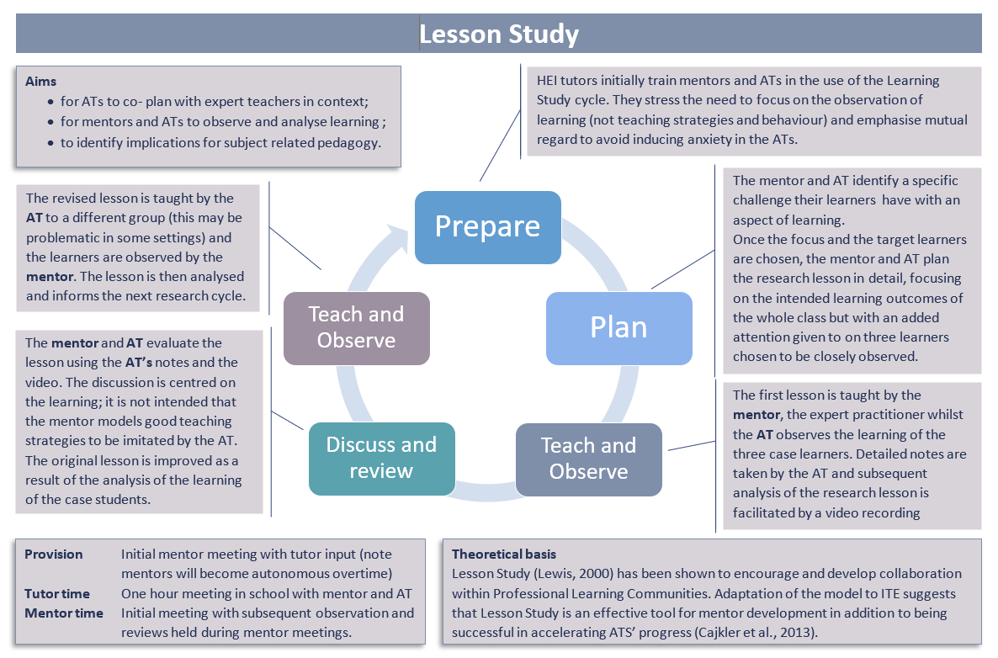

# The Knowledge Quartet

The third reflective instrument is also a set of questions; this time they are classified according to four different types of knowledge known as the **Knowledge Quartet** (Rowland et al. 2005)

|  |  |
| --- | --- |
| **Foundation knowledge**  **(SMK)** | **Transformation knowledge**  **(PCK)** |
| What did the teaching and learning in this lesson reveal about:   * the teacher’s subject knowledge; * their knowledge of the curriculum; * their beliefs about the nature of the subject; * their beliefs about teaching and learning; * their knowledge of the pupils? | Which teacher activities (demonstrations, practical work, instructional materials and assessment) did the teacher use to facilitate the pupils’ learning?  Why did they choose these methods?  Was it clear to pupils what they were supposed to be doing, why they were doing it and what they would be learning?  How did the teacher support the pupils to understand concepts?  What helped the pupils to learn? (When did the pupils learn the most during the lesson?) |
| **Connection knowledge** | **Contingency knowledge** |
| How did the teacher make connections between activities during the lesson?  How did the teacher ensure a logical sequence of activities?  How did the teacher make connections with prior and future learning?  How did the teacher link the learning objectives with the activities?  How did the teacher link the activities to the curriculum? | How did the teacher respond to students’ ideas?  Were there instances of unplanned events occurring: e.g. a student asking an unexpected question, a lack of resources or something ‘going wrong’? If so, what were they and what did they signify?  How did the teacher respond/cope? |

# Brookfield’s Lenses

And finally, Brookfield (1998) uses four lenses to analyse professional reflection:

|  |  |
| --- | --- |
| **Autobiographical** | **Learners’ Eyes** |
| How does our own history influence the ways we behave?  We must consider:   * how personal experiences have influenced our beliefs * why we choose certain approaches over others * how our own failures and successes influence our choices of pedagogy. | What do the learners think of me and the way that I teach? We should:   * create a safe space for pupil voice. * be sensitive to their needs during lessons and respond sensitively * adapt our teaching and planning according to their needs. |
| **Colleagues’ Experience** | **Theoretical Literature** |
| Having critical conversations with peers enables us to:   * gain an additional perspective * evaluate more effectively and critically * broaden our approaches * change our practice. | Reading academically literature can:   * help me identify and label my teaching approaches or pedagogy * explain success and failure * explain the complexity of the classroom * introduce me to new and effective approaches |

[Brookfield, S., 1998. Critically reflective practice. *Journal of Continuing Education in the Health Professions*, *18*(4), pp.197-205.](https://www.kent.ac.uk/teaching/documents/academic-practice/New%20to%20teaching%20Staff/Brookfield%20models%20of%20reflective%20practice.pdf)

# CABAN’s Eight Steps of AC Development

**Stage 1**

*Focus:* Begin to understand how learning is planned for in different contexts and at different stages of development (holistic development)- supports assessment.

**Stage 2**

*Focus*: Further consolidate and build on awareness of planning for learning in different contexts (holistic development) and managing behaviour and learning. Begin to understand assessment and its impact on pupils' learning.

*Developing practice:* Micro teaching/team teaching/guided mentor phased teaching (up to 30%)

**Stage 3**

*Focus*: Further consolidate and build on planning for learning in different contexts (holistic development)/Focus on short term planning.Begin to identify ways in which cross-curricular responsibilities can be embedded and develop awareness of subject specific pedagogies (Subject Studies 1.1, Literacy and Numeracy). Identify the personal literacy and numeracy skills in need of development.

*Developing practice:* progress from microteaching/team teaching as appropriate to more autonomy and fuller lessons (responsibility for planning and delivering 3-5 hours of lessons).

**Stage 4**

*Focus*: Further consolidate and build on planning for learning (holistic development).

*Developing practice:* Autonomy and fuller lessons (responsibility for planning and delivering 8 hours of lessons).

**Stage 5**

*Focus*: Debrief and reflect on first school experience. Develop expertise in research methods (action research and further data collection methods). Observation and reflection in the previous primary phase.

**Stage 6**

*Focus*: Critical observation of effective practice. Planning and teaching in a new context.

*Developing practice:* Increased autonomy and complete lessons (responsibility for planning and delivering 12 hours of lessons).

**Stages 7 - 8**

*Focus*: Consolidation of Skills and Practice.

*Developing practice:* Achieving autonomy and teaching complete lessons with responsibility for planning (using the CaBan Stage 8 Autonomous Planning sheet) and delivering up to 15-16 hours of lessons. The additional teaching may be team teaching, teaching in the 6th form, bespoke support for small groups in GCSE revision classes etc.

# Enhanced Support

Should an AT’s progress be a cause for concern then the mentor should contact the tutor immediately to initiate the Enhanced Support Programme. A typical Enhanced Support Programme provides a series of structured short-term targets and may also involve a reduced teaching workload or additional team teaching. Details of the programme can be found on our Caban Documents web page on the final page of the PSTL Handbook (use the QR code below to access the page0. Note that early intervention is far more effective and provides the AT with the greatest chance of success.



# School experience schedule

The following pages show a detailed plan of the eight stages of the School Experience Module

key

For the following pages, activities have been designed to facilitate and structure ATs’ observation and reflection. The order and timings shown are suggestions; the school, department and mentor may well want to rearrange the activities to fit with their needs.

# Week 1 Stage 1: Observation, support and reflection

# W1

# Week 2 Stage 1: (Years 0 – 2 OR 3 – 6) Introduction and observation

NB: All activities are to be provided within the constraints of the school, the class and the mentor’s timetable. This timetable is an example.

W2

**NB** On this page and the following pages, activities have been designed to facilitate and structure ATs’ observation and reflection. The order and timing shown are suggestions and the school, department and mentor may well want to rearrange the activities to fit with their own priorities.

# Week 3 Stage 2: Observation, support and team teaching

NB: All activities are to be provided within the constraints of the school and the mentor’s timetable. This timetable is an example.

W3

# Week 4 Stage 2: Observation, support, planning and team teaching

**NB** ATs take more control of lessons; they teach full lessons as agreed with the mentor and take responsibility for 3-5 hours of lessons.

All activities are to be provided within the constraints of the department and the mentor’s timetable

# W4Week 5 Stage 3: Observation, support, planning and team-teaching

ATs take more control of lessons; they teach full lessons as agreed with the mentor and take responsibility for 3-5 hours of lessons.

All activities are to be provided within the constraints of the school, the class and the mentor’s timetable

# W5Week 6 Stage 3: Observation, support, planning and teaching

ATs take more control of lessons; they teach full lessons as agreed with the mentor and take responsibility for 3-5 hours of lessons.

All activities are to be provided within the constraints of the school, the class and the mentor’s timetable

W6

# Weeks 7 – 8 Stage 4: Observation, support, planning, team-teaching, autonomy and fuller lessons

# ATs plan and teach full lessons as agreed with the mentor and take responsibility for 8 hours of lessons.

All activities are to be provided within the constraints of the department and the mentor’s timetable. The timetable below is an example.

# W7-8

# Week 9 **Stage 6**: Placement 2 in Years 0-2 or Years 3-6

ATs plan and teach full lessons as agreed with the mentor and take responsibility for 12 hours of lessons by the end of the placement.

All activities are to be provided within the constraints of the school, the class, and the mentor’s timetable. The timetable below is an example.

# Introductory Week

W9

Weeks 10 - 14 Stage 6: Teaching, observation and reflection   
ATs plan and teach full lessons as agreed with the mentor and take responsibility for 12 hours of lessons by the end of the placement.All activities are to be provided within the constraints of the school, the class, and the mentor’s timetable. The timetable below is an example.

# W10-14

# Week 15 Observation in a secondary school; to be arranged by the Network School (Monday- Wednesday)

All activities are to be provided within the constraints of the school, the classes, and teacher availability. The timetable below is an example.

# W15

# School Experience 3 Completed in the AT’s preferred years

# Week 16 Stages 7 – 8 Autonomous teaching and reflection

Should the AT have to change school at the end of stage 6, Stage 7 should include an induction week (see below); otherwise, ATs progress directly to the programme detailed on the next page.

# W16

# Weeks 16 - 26 Stages 7 – 8 Autonomous teaching and reflection ATs should teach 15 hours a week by the end of the stage.

W16-26